OPERATIONS PLAN AND SAFETY MANAGEMENT SYSTEM
THE HARBOUR OF LYME REGIS

November 2022

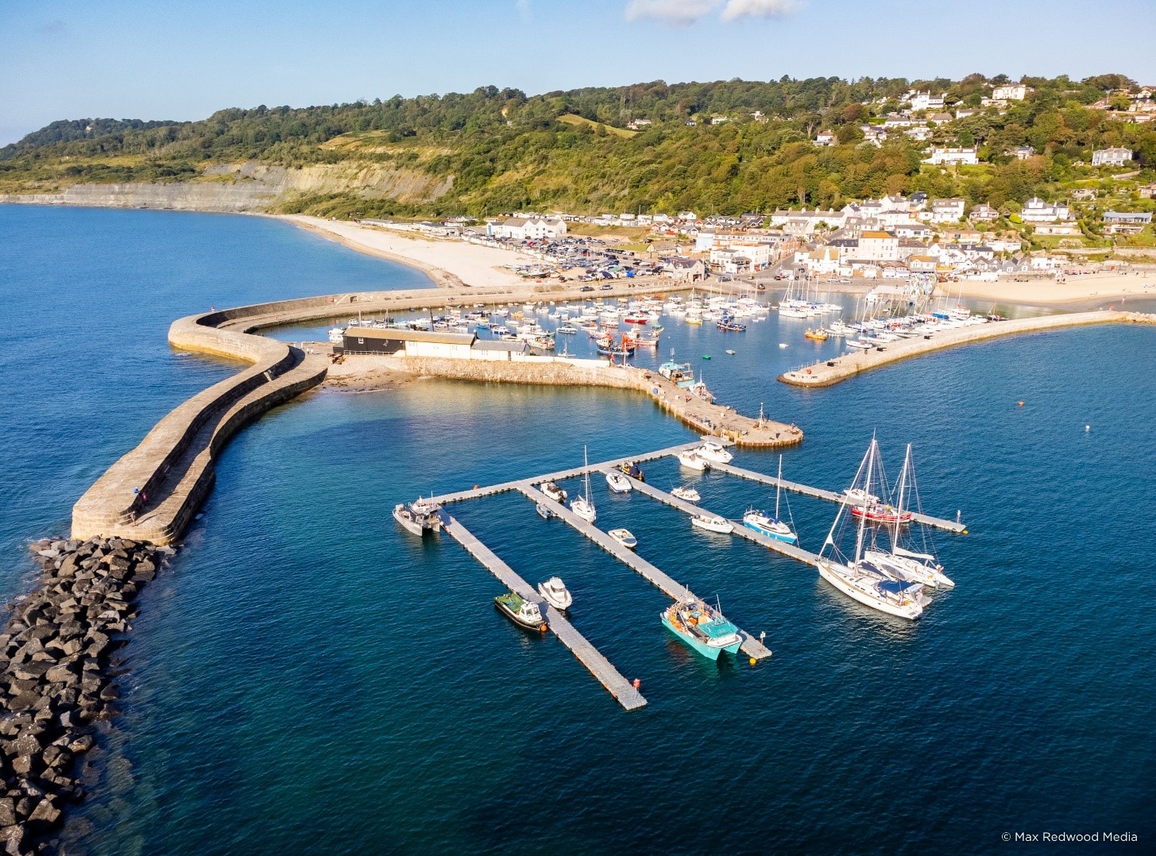

Original Prepared by: C F Spencer & Co Ltd

The Old Malt House
West Street
Banwell
Somerset
BS29 6DB

Update | Reviewed by | Date
Original Report | CF Spencer & Co Ltd | 2002
Update | West Dorset District Council | 2005
Update | West Dorset District Council | 2006
Update, Audit and Assessment | Maritime Resolve ltd. | September 2012
Update | R Noakes – West Dorset District Council  Grahame Forshaw (Harbour Master) | 2015
Update | R Noakes – West Dorset District Council  Grahame Forshaw (Harbour Master) | 2017
Amendment & update | R Noakes – West Dorset District Council  Grahame Forshaw (Harbour Master) | December 2018
Review and update | James Radcliffe (Harbour Master) | August 2019
Audit, amendment and update | James Radcliffe (Harbour Master)  Ken Buchan (Head of Environment and Wellbeing) | November 2022

CONTENTS
- THE PORT OF LYME REGIS 8
1.1 General Description 8
Photograph 1 – View to seaward across the harbour at low water 8
1.2 Harbour limits 9
Figure 1: Lyme Regis Harbour Limits 9
1.3 Anchorages 10
1.4 Ship parameters 10
1.5 Designated Nature Conservancy Sites 10
1.6 Port Users 10
Photograph 2 – View across the harbour towards shore. The ‘trot’
arrangement of boats can be seen 10
2. LEGAL STRUCTURE; PROFESSIONAL STAFF; POLICY 11
2.1 Statutory Authority 11
2.2 Legal duties and powers 11
2.3 Enabling legislation 11
2.4 By-laws 11
2.5 Harbour rules 11
2.6 Directions 11
2.7 Harbour revision orders 11
2.8 Accountability 11
2.9 Nominated responsible body 12
2.10 The designated person 12
2.11 Professional staff 12
2.12 General Management Policy 12
2.13 Marine Safety Policy 13
2.14 Systems and Standards 13
2.15 Training 13
2.16 Consultation 13
3. KEY PEFORMANCE INDICATORS 14
3.1 Operation 14
3.2 Conservancy 14
3.3 Hydrography 14
3.4 Emergencies 14
3.5 Consultation 14
3.6 Audits and Continuous Assessment 14
4. SAFETY MANAGEMENT SYSTEM 14
4.1 General 14
4.2 Introduction to the Council System 16
4.2.1 Summary 16
4.2.2 Hazard 16
4.2.3 Risk 16
4.2.4 Risk Assessment 16
Figure 2 – Summary of Risk Assessment Process 17
4.3 Responsibilities 17
4.4 Categories of Risk Diagram 19
Figure 3 – Categories of Risk Diagram 19
Figure 4 – Table of Risk Level 19
Figure 5 – Table or Risk Level and Acceptability 20
4.5 Generic Risk Assessments 20
4.6 Review of Risk Assessments 20
Figure 6 – Plan, Do, Check and Act 21
4.7 Lyme Regis Harbour Safety Management System Hazard and Risk Management 22
4.8 Safety 22
4.9 Lines of Authority 23
Figure 7 – Harbour Governance Structure 23
Figure 8 – Staff Structure Lyme Regis Harbour 24
4.10 Structure of the Safety Management System 24
4.11 Free Standing Plans now Adopted into the System 24
4.12 Integration of the Elements 25
Photograph 3 – Harbour Mouth at Half Tide 25
5. OPERATIONS PLAN 25
5.1 Overview 25
5.2 Berth operators and private users 25
5.3 Freight 25
5.4 Leisure Uses 25
5.5 Moorings 26
5.6 Pontoons 26
5.7 Fishing Vessels 26
Photograph 4 – Fishing boat discharging cockles at harbour mouth at
low water 27
5.8 Charter Boats 27
5.9 RNLI Lifeboats 27
5.10 Passenger Ships 27
5.11 Hazardous Goods 27
5.12 Port management and marine safety 27
5.13 Communications 28
5.14 Collision Regulations 28
5.15 Speed Limits 28
5.16 Vessel Traffic Services (VTS) 28
5.17 Pilotage 28
5.18 Passage Plan 28
5.19 Training and Qualifications 28
5.20 Dangerous Vessels 29
Photograph 5 – Rear of Cobb Wall in outer basin showing original
construction 29
5.21 Wrecks 30
5.22 Conservancy 30
5.23 Standards and Inspection of Aids to Navigation 31
5.24 Dredging, Hydrography and Admiralty Charts 31
Photograph 6 – West side of Cobb wall showing modern construction 31
5.25 Meteorology 31
5.26 Tugs 32
5.27 Works Licensing 32
5.28 Event Management 32
5.29 ISPS 33
6. EMERGENCY RESPONSE PLAN 33
6.1 Assigned Areas of Responsibility 33
6.1.1 All vessels in the harbour approaches 33
6.1.2 Craft in the harbour 33
6.1.3 All craft alongside in the harbour 33
6.2 SOSREP 33
6.3 The Plan 34
6.3.1 General 34
Figure 9 – General Emergency Response Flowchart 34
6.3.2 Pollution 34
6.3.3 Tug and Salvage Equipment Availability 34
6.3.4 HM Coastguard 35
6.3.5 RNLI 35
6.3.6 Vessels Aground 35
6.3.7 Wrecks 35
6.3.8 Persons in Difficulties in the Water 36
7. REPORTING, ASSESSMENT AND AUDIT 37
7.1 Overview 37
7.1.1 External Reporting 37
7.1.2 Internal Reporting Chain 37
7.2 Continuous Assessment 37
7.3 Investigation and Reporting 37
7.4 The audit trail 38
7.4.1 Introduction 38
7.4.2 Twelve Monthly Review 38
7.5 External Reporting 39
7.6 Reporting of Incidents, Accidents or Disasters 39
7.7 Internal Investigation and Reporting 39
7.8 Reporting 40
7.9 Public Scrutiny 40

- THE PORT OF LYME REGIS

  - General Description
Lyme Regis harbour lies in 50° 43’N, 002° 56’W, about halfway along the Lyme Bay coast. It is a very ancient harbour with recorded activity dating back to the twelfth century and was once one of the foremost ports in England. Those days are long gone, however, and now the harbour accommodates small fishing boats and yachts. It consists of a substantial Western breakwater, the Cobb, with Victoria Pier branching from this to the East. These, along with the detached North Wall, form a basin which constitutes the harbour. The landward side has been filled in by a substantial sand bank which now links the North Wall with the Cobb and the shore; this beach is very popular with the public.
Formerly, Cobb was a separate village which gave its name to the harbour; nowadays it is incorporated into Lyme Regis although still somewhat detached geographically. The Cobb breakwater itself is now a Grade 1 listed structure. The harbour dries at low water except for a pool of deeper water in the harbour mouth which allows shallow draft craft to remain afloat at the passenger steps.
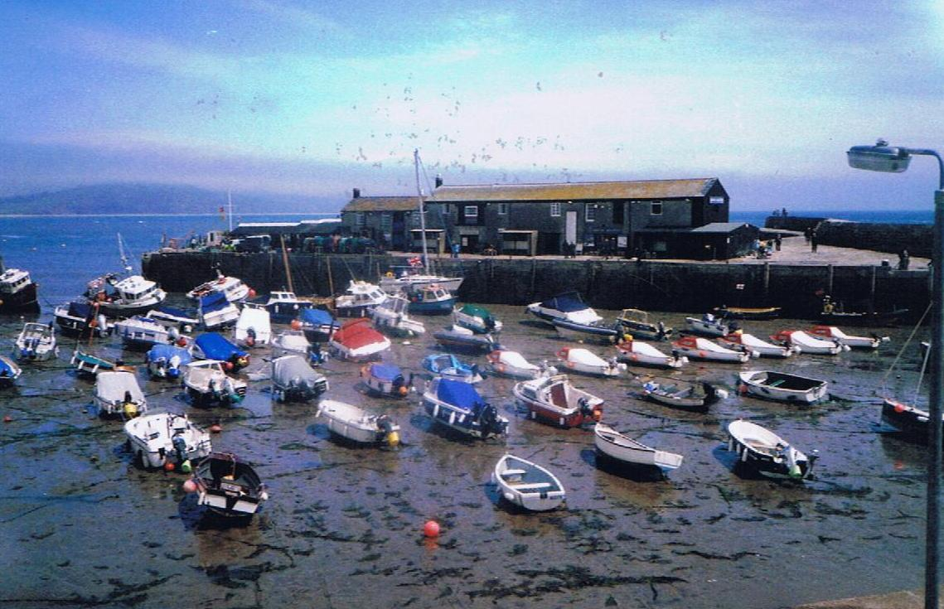
Photograph 1 – View to seaward across the harbour at low water.

  - Harbour Limits
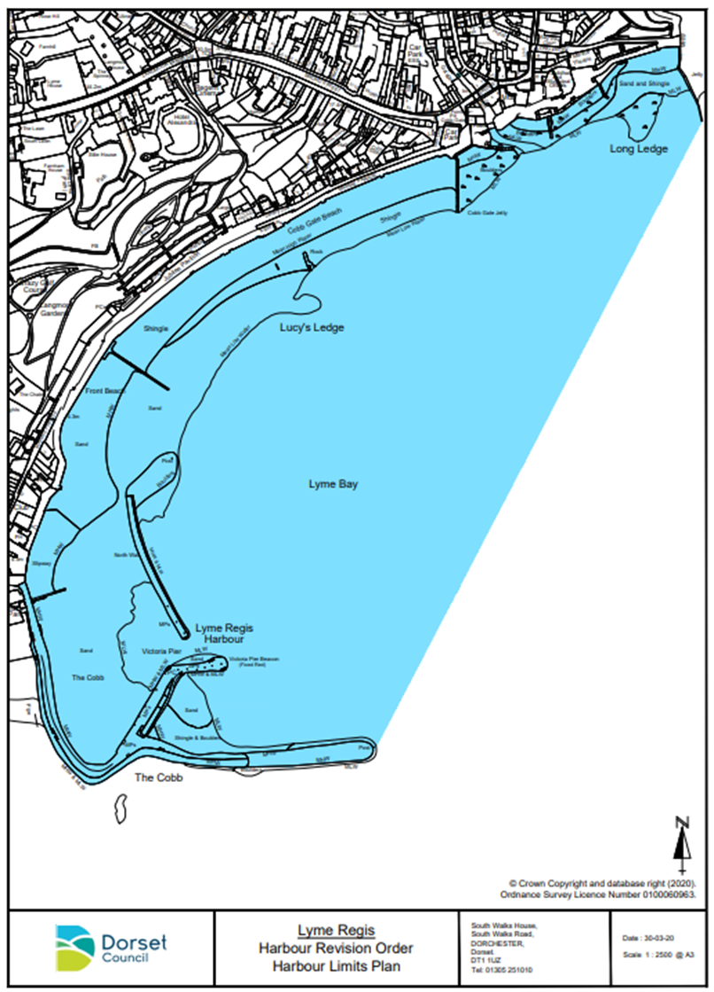

Figure 1 – Lyme Regis Harbour Limits

The tidal range at Lyme Regis is 4.5m at maximum spring tides, 1.0m at slackest neaps. The inner Harbour dries out. Strong southerly and particularly south-easterly winds send in an uncomfortable surge into the harbour and makes the outer harbour area completely unusable for berthing or mooring. Although subject to draft considerations, access is straightforward in suitable weather conditions, night, or day.
1.3 Anchorages
There are no designated anchorages at Lyme Regis.
The bay area is completely open from South-East through South to West and offers no shelter to weather from those sectors. A choppy sea can get up very rapidly in Lyme Bay when the wind rises from an exposed quarter.
At Lyme Regis, small vessels can anchor 900m Southeast of the harbour entrance, but there is no shelter. In sailing ship days Lyme Regis harbour was a port of refuge for vessels embayed in Lyme Bay but unable to anchor due to stress of weather.
1.4 Ship Parameters
At Lyme Regis, vessels up to 10m length, 3.8m beam, and 2m draught are regarded as the maximum size nowadays, although larger coastal traders used the port in previous times. Generally, only small fishing boats and yachts enter the harbour and moorings can hold vessels up to a maximum of 8m in length.
1.5 Designated Nature Conservancy Sites
Lyme Regis harbour limits are located inside the boundary of the Lyme Bay and Torbay Marine Special Area of Conservation. The entire coast from Sidmouth to West Bay/Bridport is an SSSI and much of it also an SAC. The Jurassic Coast World Heritage Site extends from Orcombe Point in Exmouth to Old Harry Rocks near Swanage, its boundaries broadly defined as between mean low water mark to the top of the cliffs or back of the beach.
1.6 Port Users
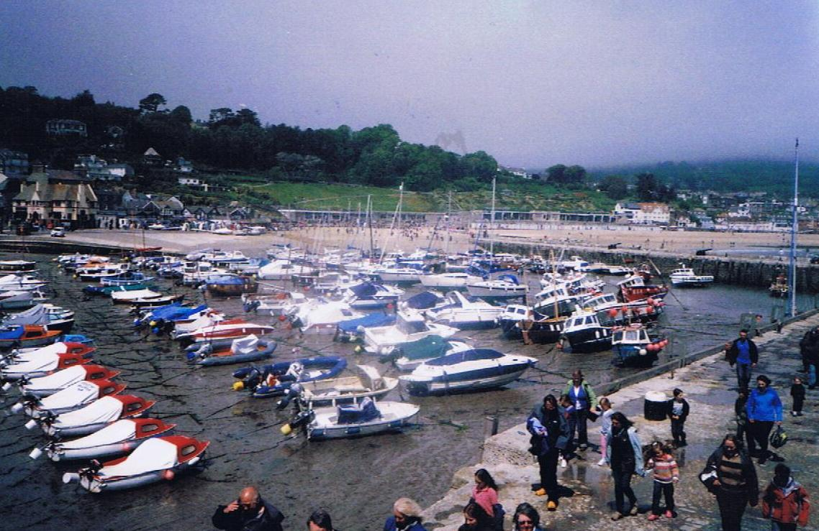
The harbour is normally taken up with small craft. Commercial users are small inshore fishing boats and charter boats but the main users are pleasure craft. The basin is entirely filled by these craft which virtually all lie to trots of moorings laid in the harbour.

Photograph 2 – View across the harbour towards the shore.
The ‘trot’ arrangement of boats can be seen.
- LEGAL STRUCTURE; PROFESSIONAL STAFF; POLICY
2.1 Statutory Authority
Dorset Council is the Statutory Harbour Authority (SHA) for Lyme Regis. Lyme Regis is not a Competent Harbour Authority within the meaning of the Pilotage Act 1987 but nevertheless conforms to the Port Marine Safety Code. The SHA is answerable to its electorate via the councillors both in direct approaches and at the ballot box.
2.2 Legal Duties and Powers
Lyme Regis is an open port, into which any user has a right to navigate on payment of harbour dues. There is a duty to operate it safely for the benefit of all such users. The berths and wharves and seasonal pontoons are under the control of the Harbour Master.
2.3 Enabling Legislation
Lyme Regis operates under an act of 1821. This Act confirms the status of an Act from the thirty-fifth year of Queen Elizabeth I’s reign, which appears still to have legal force. However, a Harbour Revision Order was submitted to the Marine Management Organisation in 2021, and this is still being considered for approval and will update the legislation around harbour operations.
2.4 By-laws
Lyme Regis Harbour has four sets of by-laws still current. In addition, a general set of Dorset Council by-laws, mainly concerned with conduct on roads and in public places, has force in the harbour area.
2.5 Harbour Rules
Boat owners at Lyme Regis are required to comply with additional rules; a copy is published on Lyme Regis Harbour in Dorset These are largely taken up with rules for moorings.
2.6 Directions
There are no directions extant.
2.7 Harbour Revision Orders
There are no Harbour Revision Orders in force, but one has been submitted and Dorset Council is currently awaiting approval.
2.8 Accountability
Dorset Council as the SHA is accountable for its duties and powers. Its discharge of this responsibility is measured against nationally agreed standards as laid down in the Port Marine Safety Code and amplified in the Code’s accompanying Guide to Good Practice.

2.9 Nominated Responsible Body
Under the terms of the Port Marine Safety Code, the Portfolio Holder for Highways, Travel and the Environment is the Duty Holder.
2.10 The Designated Person
The Designated Person for Bridport, Lyme Regis and Weymouth Harbour is James Hannon (Associate Maritime Consultant, ABPmer).
2.11 Professional Staff
Dorset Council employs a Harbour Master, a full time Assistant Harbour Master, a full time Harbour Assistant, and a Business Support Officer. Two further harbour assistants are employed for the season. These staff members have day-to-day operational responsibility for the Harbour.
2.12 General Management Policy
As required by the “Code”, Dorset Council publishes its policies, plans and periodic reports, setting out how they comply with the Code’s standards, and these are found below.
A document ‘Harbour Policy’ is also published on Harbour Policies - Lyme Regis Harbour which regulates much of the activity in the harbour.
Dorset Council as the Statutory Harbour Authority (SHA) is committed to undertaking and regulating marine operations to safeguard the harbours, their users, the public and the environment.
The authority aims to run a safe, efficient, cost-effective, sustainable harbour operation for the benefit of all users and the wider community.
The authority aims to meet the national requirements in the Port Marine Safety Code, and fulfil its legal responsibilities whilst endeavouring to meet the changing needs of harbour users.
The Council will support the commercial, fishing, and recreational activities in the harbours through the provision of appropriate services of good value.
The policy of the Council is to:
- Manage the assets of the Authority safely, economically and efficiently.
- Train the operational staff and ensure they are properly trained in emergency and contingency procedures.
- Regulate traffic within the harbour limits to ensure safe and efficient movements.
The SHA and its authorised officers are aware of their environmental commitments. The local environment of Lyme Regis Harbour is considered important and the impact on it will be a material consideration if any changes to the existing situation are proposed.

2.13 Marine Safety Policy
The Council and its staff will ensure marine safety by:
- Providing a safe environment for navigation through aids to navigation and conservancy.
- Regulating activities within the port as required by statute.
- Training and educating staff, users and the public in safety awareness.
- Ensure as far as reasonably practicable the safety at work of its employees and other people who may be affected by its activities.
- Application of the Port Marine Safety Code and its supporting Guide to Good Practice through this Marine Operations Plan.
2.14 Systems and Standards
The plans established in this document have been developed on the basis of a formal risk analysis, and a Safety Management System evolved in response to that risk analysis. It is based on the “As Low As Reasonably Practicable” (ALARP) principle, which aims to reduce risk levels to the lowest practical level.
2.15 Training
The harbour has a full training policy. All Councillors as part of the Full Council and specifically Harbours Committee members and Duty Holder are expected to undertake appropriate lectures to give them an understanding of their duties and responsibilities, particularly regarding the Port Marine Safety Code and its application. Training is conducted at least annually and as necessary to match the election cycle of the Council.
Professional staff officers are properly qualified for their duties, with the current Harbour Master having completed all mandatory training. Any new marine staff will be required to train and obtain appropriate qualifications for their role in the harbour if they do not have correct qualifications already.
A programme of updating knowledge and renewing qualifications when required, is pursued and records kept of all staff qualifications and training.
2.16 Consultation
Representatives of all regular user groups were consulted in the creation of this Code. Provision is made under the continuous assessment procedure for any change which affects a consultee to be consulted before or at the time of any such change.
In the course of preparation of the PMSC Plan for Lyme Regis, the following were consulted:
- Harbour Staff
- Fishermans’ Association
- Lyme Regis Sailing Club
- Lyme Regis Power Boat Club

The Lyme Regis Harbour Consultative Group which is comprised of representatives of the main harbour user groups are kept informed of changes to harbour operations and consulted where appropriate.
- KEY PERFORMANCE INDICATORS
Dorset Council considers the following key responsibilities apply to its ports, all of which conform to the best practice requirements of the Port Marine Safety Code and its appending Guide to Good Practice.
  - Operation
To operate the port and regulate vessel movements for a 100% incident-free service.
  - Conservancy
To maintain and operate all navigation marks and lights to at least IALA standards and confirm to Trinity House reporting procedures.
3.3 Hydrography
The Harbour will be surveyed as and when necessary, by professional surveyors. Where appropriate the results will be notified to the Hydrographer of the Navy.
3.4 Emergencies
To carry out one major exercise per year.
To ensure ongoing training is maintained in all emergency procedures at the port.
3.5 Consultation
Both commercial and leisure user representatives meet regularly as part of the Lyme Regis Harbour Consultative Group normally in April and October (pre and post season), but the Harbour Master is available on a daily basis to discuss with boat owners and operators any areas of concern.
3.6 Audits and Continuous Assessment
Ensure continuous assessment is carried out with periodic internal reviews of all port functions.
Carry out a full formal audit at not more than three year intervals, of all port functions and report the results publicly.
- SAFETY MANAGEMENT SYSTEM
4.1 General
The purpose of this document is to specify the content of the Marine Safety Management System (MSMS) which shall describe the means by which the Statutory Harbour Authority (Dorset Council), and the Portfolio Holder for Highways, Travel and Environment as Duty Holder for the safe and effective management of marine and environmental affairs will carry out this responsibility within its jurisdiction at Lyme Regis Harbour.

The Port Marine Safety Code (PMSC) refers to some of the existing legal duties and powers that affect Harbour authorities in relation to marine safety, but it does not in itself create any new legal duties for Harbour authorities. There are however several additional measures which, although not mandatory under legislation, are key to its successful implementation.

In order to comply with the PMSC therefore, Harbour Authorities must:

- Be aware of their existing powers and duties.
- Appoint someone as an independent “Designated Person” with direct access to the Duty Holder
- Develop an effective marine safety management system, which employs formal risk assessment techniques.
- Employ people who are competent and qualified for the positions they hold.
- Publish a comprehensive safety plan, along with a regular assessment showing the authority’s performance against the plan.

The Marine Safety Management System should be in place to ensure that all risks are controlled – the more severe ones must either be eliminated or kept ‘‘as low as reasonably practicable (ALARP)”.

Lyme Regis Harbour also uses the safety and risk management system of its owner, Dorset Council. It defines risk management as “the culture, processes and structures that are directed towards effective management of potential opportunities and threats to the organisation achieving its objectives”.

At its highest level the Council’s risk management strategy requires that the wider implications of the port’s operations at a political, financial and social level should be built into the risk management system.

Lyme Regis is particularly busy throughout the summer months, with homes, bars, and restaurants, and shops in close proximity to the harbour, and along marine parade which overlooks the wider extent of the harbour limits. This means that the effects of its Safety Management System spread beyond the marine consequences of the PMSC’s definition of risk. Where specific hazards would have their own specific responses under the PMSC, with steps identified to eliminate or control them to ALARP levels, the broader vision of the Council’s approach also requires those much wider factors to be considered.

The Council and harbour staff have a wide range of stakeholders to whom they answer: the Council as the Statutory Harbour Authority and Duty Holder, the people of the area to whom the Harbour is an important aspect of their lives, its many direct stakeholders and users whose livelihoods may depend on it, the many visitors and not least the professional staff whose job it is to run the Harbour.

The Council’s approach to risk also requires that the financial consequences of the harbour's operations are not put at risk while the PMSC requires that the harbour is properly maintained to be a safe harbour for all users. As an open harbour, available to all craft able to fit into it against the payment of proper dues, there is a direct legal requirement that it is fit to be used. Such maintenance costs money and the balance between finance and physical safety is constantly under review through the risk management system.
4.2 Introduction to the Council System
4.2.1 Summary
A statutory requirement, and central to the management and control of risks from hazards, is the use of risk assessments. A risk assessment is a paperwork exercise to review any work situation that allows relevant risks to be identified, recorded, communicated, and reduced where it is reasonable to do so. A duty exists for Dorset Council to reduce risk to the lowest reasonably practicable level. This duty extends to ensuring that risk assessments are suitable and sufficient and identify measures to be taken that ensure work tasks are safely undertaken.
4.2.2 Hazard
Something with a potential to cause harm. A situation that could occur which has the potential for human injury, damage to property, damage to the environment, or economic loss.
4.2.3 Risk
An estimation of the likelihood and potential consequences of a defined hazard, risk expresses the likelihood that the harm from a particular hazard is realised. Risk therefore reflects both the likelihood that harm will occur and its severity.
4.2.4 Risk Assessment
Risk assessments should normally be completed using a template which can be sourced from the Council’s forms register. Workplace areas with higher risk, i.e., harbours, may determine that a different and more comprehensive risk assessment template is more appropriate. The same principles of the risk assessment process will still apply.

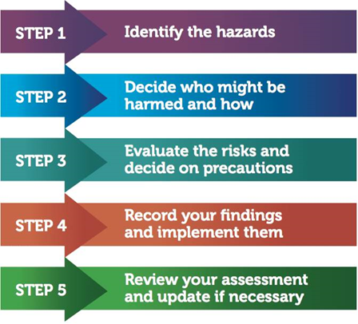
Figure 2 – Summary of Risk Assessment Process

4.3 Responsibilities
Service managers should ensure that risk assessments are completed for all staff under their control. Line managers should ensure that members of staff who undertake risk assessments are competent to do so, have a good level of subject knowledge and are aware of the limitations of their expertise. Staff should be advised to seek further advice if needed.

Members of staff charged with undertaking risk assessments (Assessors) should be suitably trained in order that risk assessments undertaken are both suitable and sufficient and have the benefit of reducing risk. Risk assessment training can be sourced through the Health, Safety and Welfare Officers.

To help further understand the method for assessing risk Dorset Council have adopted a matrix that allocates numbers to judgements made. The higher the severity and likelihood, the higher the number between one and four is selected. Once numbers replace judgements these can be multiplied together to give a risk rating.

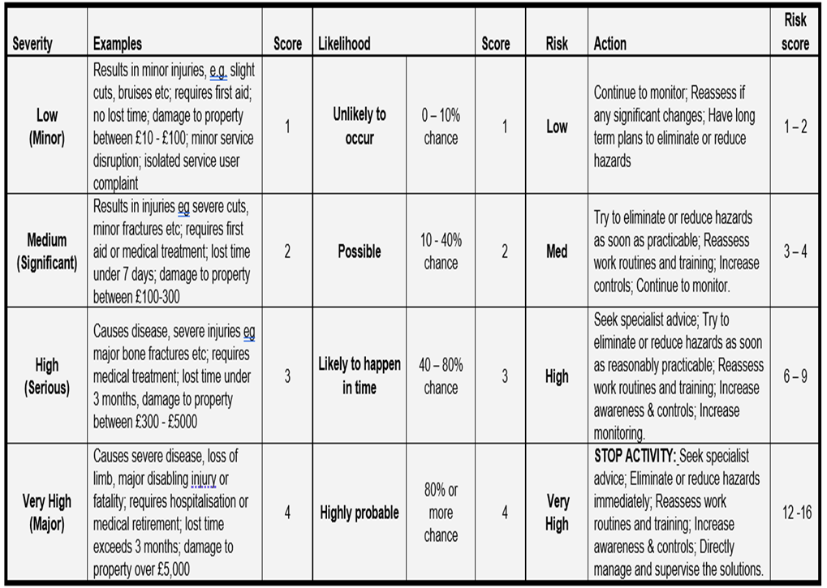

Five steps to risk assessment:

1. Look for the hazard.
2. Decide who might be harmed and how.
3. Evaluate the risk and decide if existing controls are adequate or more should be done.
4. Record the findings.
5. Review periodically or when significant changes occur.

Refer to:

Dorset Council Risk Assessment Policy & Procedure
Health and Safety Executive subject guidance
Manufacturers’ Handbooks and web sites
Training Manuals
Codes of Practice
Existing workforce knowledge
Accident reports and other appropriate sources of information

4.4 Categories of Risk Diagram

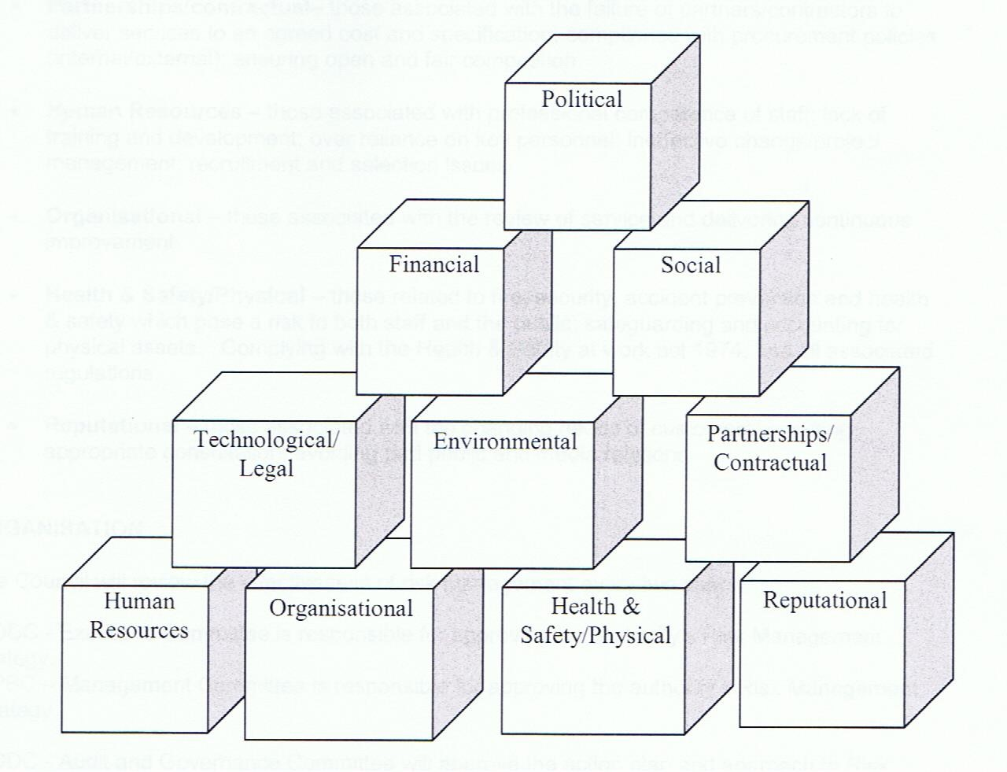
Figure 3 – Categories of Risk Diagram
There is some overlap between this set of considerations, and those of the PMSC but also extra elements which between them provide for a comprehensive view of risk management.

The Council risk registers lay out the matrices of risk level and acceptability. The non-marine risks of the port are assigned levels from within these matrices, and the Safety Management System demonstrates how they are managed. The specific marine hazards that come within the definitions of the PMSC, by being assigned values from within the Council matrices, are incorporated in one cascading system. All the hazards and risks identified are catalogued in The Risk Register Document. Two of the comprehensive risk management system matrix systems are shown:
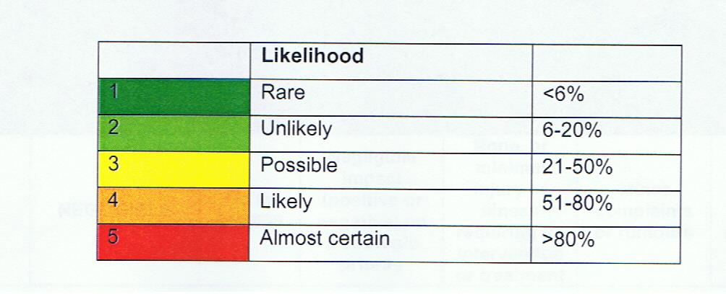
Figure 4 – Table of Risk Level

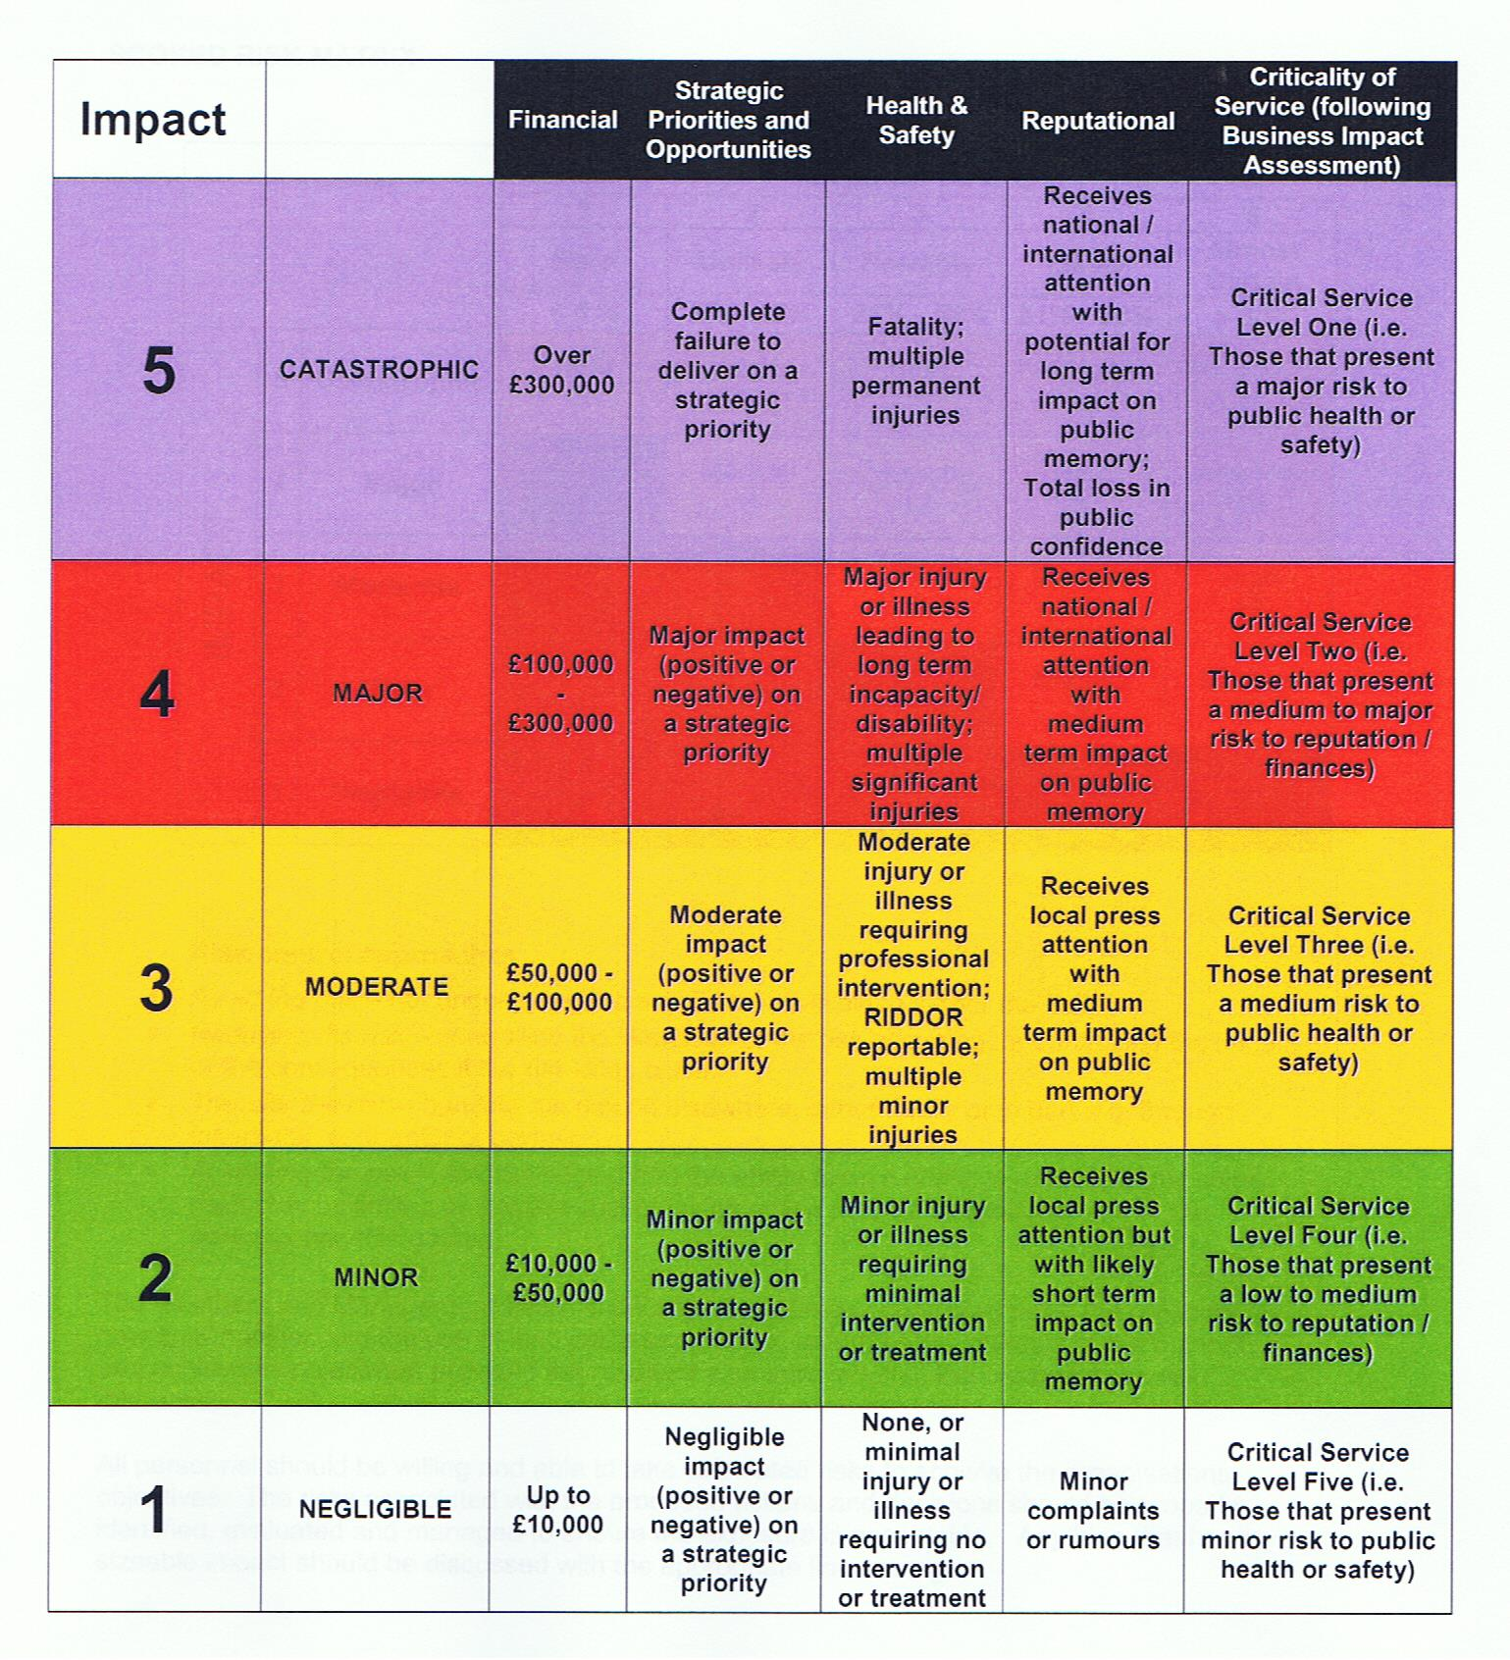
Figure 5 – Table of Risk Level and Acceptability
4.5 Generic Risk Assessments
Several generic risk assessments against common hazards were provided by Dorset Council as a framework for services to use and adapt. These will be adopted by the Harbour to avoid unnecessary effort. The following are available to date:

1. Management of Health and Safety at Work | 2. Risk Assessment
3. Accidents, Incidents and Disease | 4. Asbestos
5. Confined Spaces | 6. Construction (Design and Management) regulations 2008
7. Contractors | 8. COSHH
9. Display Screen Equipment | 10. Fire Risk Management
11. Health and Safety Training | 12. Home Working
13. Lifting Operations and Lifting Equipment | 14. Management of Workplace Stress
15. Manual Handling | 16. New and Expectant Mothers
17. Noise at Work | 18. PAT Testing
19. PPE | 20. Provision and Use of Work Equipment
21. Road Safety | 22. Safety Signs
23. Slips and Trips | 24. Travelling Officers and Lone Workers
25. Working at Heights | 26. Young People

4.6 Review of Risk Assessments
The Harbour risk registers and assessments will be reviewed:

- whenever a new activity is started
- at least on a minimum annual basis in accordance with Dorset Council policy
- whenever an accident or incident occurs
- when significant changes occur to work practices that may impact on health, safety and welfare.

The review will normally be led by the Harbour Master and will consult Harbour Staff, Dorset Council experts and external assistance including the Harbour Consultative Group. The risk assessment methodology is demonstrated under the plan, do, act and check philosophy as shown on the next page.
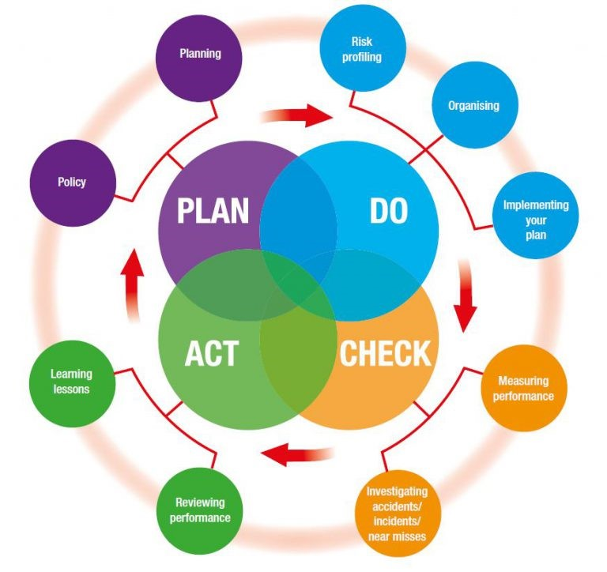
Figure 6 – Plan, Do, Check and Act

4.7 Lyme Regis Harbour Safety Management System Hazard and Risk Management
The port of Lyme Regis has a long history of offering shelter to vessels in the Eastern half of Lyme Bay where, especially in sailing ship days, they could all too easily become embayed. To fulfil this function it had to be a safe, reliable harbour easy of access. It remains so today, and in general can be assessed as a low risk port. There are certain features which can be problematic: it is a drying harbour, so not so accessible around low water. In winter, green seas can break right over the Cobb and cause disturbance in the harbour basin. It is also a very popular multi-use facility which can cause passing problems from time to time. As the Harbour Master or a deputy is often on his own at weekends, much of his time is taken up with practical accident prevention and general supervision in the harbour.
The Port Marine Safety Code requires that each port’s powers, policies, plans, and procedures must be based on a formal assessment of hazards and risks. Harbour authorities must have formal safety management systems.
To comply with this, the hazards within the port of Lyme Regis have been identified, the risks associated with each evaluated, and the element of the Safety Management System which applies to that risk described.
List of Hazards Identified:
1) Harbour Mouth.
2) The ‘Thunderbore’.
3) Extreme Winter Weather.
4) Vessels Refuelling.
5) Fire.
6) Moving craft on Slipways and in boat parks.
7) The Harbour Beach area and swimming.
8) Loading and unloading goods.
9) Passengers embarking and disembarking.
10) Persons falling from piers.

Hazards and associated risks are outlined in detail in an accompanying risk register to enable frequent review and update.
4.8 Safety
Safety is not a separate discipline isolated from the workings and day-to-day life of a port. The full and proper application of safety measures allows an incident-free and safe working environment in which ships go about their business without hazard.
The objective of the Port Marine Safety Code is to ensure that every element in a port’s operation follows the same unitary system of safe working practices, and that working within this Code is automatic and embedded in the way everyday activities are carried out. To this end it prescribes lines of authority, actions to be taken, and the way in which the port’s activities are to be carried out to achieve that level of safety.
Within the Marine Operations Plan for each port, safety has been integrated at all levels.
4.9 Lines of Authority
Lyme Regis Harbour has a simple and effective line of authority. The Harbours sit under Place Services in Dorset Council. Dorset Council is the Statutory Harbours Authority. The Portfolio Holder for Highways, Travel and the Environment is the Duty Holder. Daily operations are performed by harbour staff with the Harbour Master reporting to the Head of Environment and Wellbeing who in turn reports to the Corporate Director for Place Services. Dorset Council’s Harbours Committee play and advisory role. The Harbour Master reports formally to the Committee and Duty Holder at quarterly committee meetings but has access to the Duty Holder at any time.
The Harbour Master, supported by the Harbour staff, has day to day responsibility for managing the safe operation of navigation and other marine activities in the area of jurisdiction. He/She is authorised to act on behalf of the Duty Holder in the course of his/her duties to meet the requirements of the Port Marine Safety Code, Business Plan and Harbour Budget. The Harbour Master is authorised to exercise all powers granted by statute to his position.
In the absence of the Harbour Master, the Assistant HM will manage day to day operations.
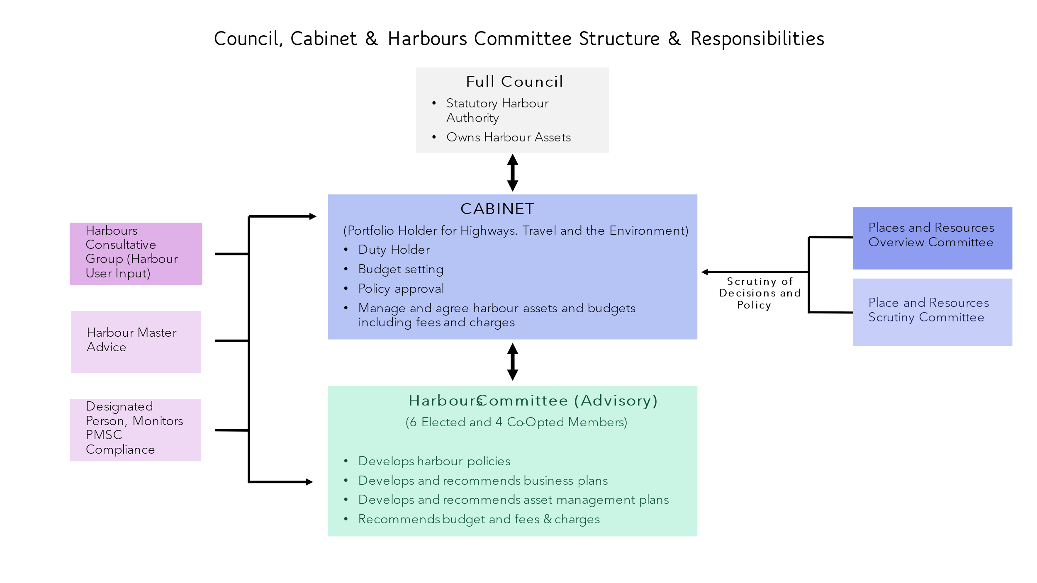
Figure 7 – Harbour Governance Structure

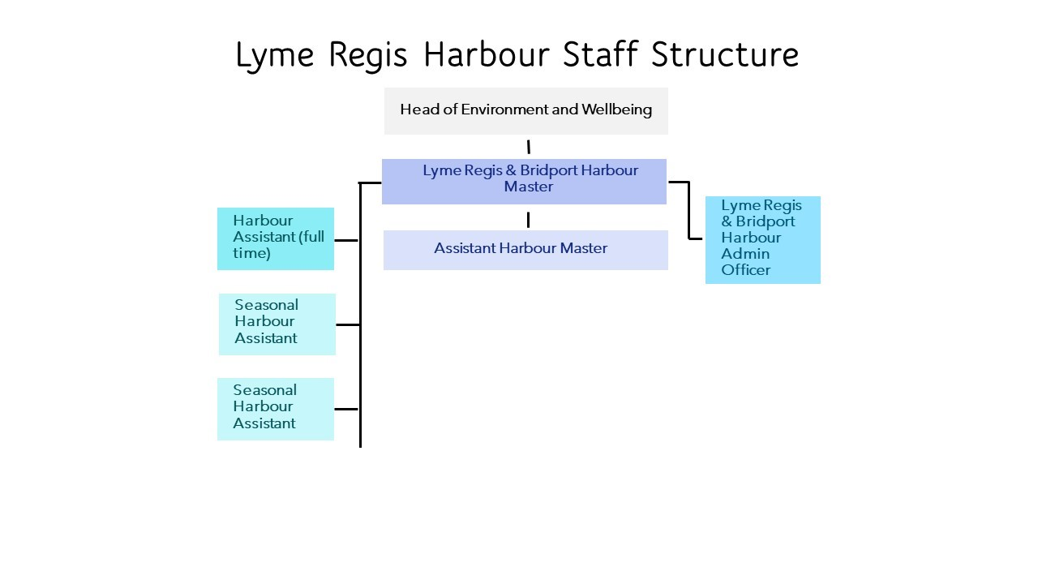
Figure 8 – Staff Structure Lyme Regis Harbour

4.10 Structure of the Safety Management System
The Safety Management System provides a framework for the operation of the port and is in three parts:
Port Procedures: The port procedures lay down the practical day-to-day working practices of the port.
Risk Assessment: The Formal Risk Assessment identifies and grades the risks likely to occur within both ports.
Response Plan: Responds to risks identified in the formal risk assessment.
4.11 Free Standing Plans now Adopted into the System
There are three plans adopted into the Safety Management System:
- Dorset Council Civil Emergencies Plan.
The Dorset Council Emergency Plan lays out the systems to be used for any emergency in the County. Should any incident in the harbour area have consequences reaching beyond its confines, it is the regional plan which will be brought to bear.
- Coastal Oil Pollution Response Plan.
The Harbour is below the size limit for the requirement to have individual oil pollution response plans, but are party to the Dorset Coastal Plan.
- Waste Management Plans.
There is a Dorset Council waste management plan, See link below:
Waste Management - Lyme Regis Harbour
4.12 Integration of the Elements
Only a limited number of people are involved in running the port: there is a clearly defined senior officer, the Harbour Master, in charge of all practical marine matters. His reporting line is also short and clear, and hence the scope for uncertainty or confusion is minimised.
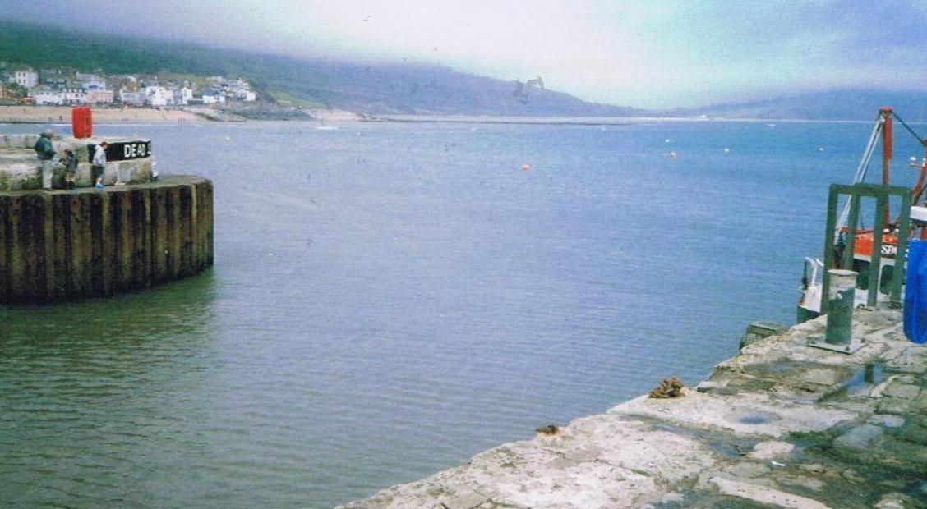
Photograph 3 – Harbour Mouth at Half Tide
- OPERATIONS PLAN
5.1 Overview
The operations plan for Lyme Regis is based on the port being used entirely by small craft, many of them local, which are both manoeuvrable and familiar with the port. Therefore, major structured arrangements and plans are not needed to ensure safe navigation. Despite this, the port has its own demands, and it is necessary to have a plan to accommodate these, and to keep the disparate users of the port from causing problems for each other.
5.2 Berth Operators and Private Users
The owner of any vessel using the harbour shall ensure that whoever has charge of his craft is familiar with, and complies with, the conditions of mooring and any other harbour regulations from time to time in force.
5.3 Freight
There is no freight traffic in Lyme Regis.
5.4 Leisure Uses
Lyme Regis is primarily a leisure harbour nowadays. It has around 240 pleasure craft moorings and about 100 sailing dinghies frequently launched to race in the Bay. Lyme Regis also has extensive visiting leisure traffic with around 400 visiting yacht calls each year. During the peak period in July and August there can be several hundred small craft movements per day, comprising local charter boats, visiting yachts, powerboats, and many small inflatables. A dry storage for 100 kayaks is also provided.
5.5 Moorings
Lyme Regis harbour is extensively filled with 240 moorings. These are strictly controlled by the Harbour Masters on behalf of Dorset Council, which has the sole authority to authorise moorings. Most moorings in both harbours are in trots, laid to ground chains across the harbours. Both the ground chains and risers are provided by the Council, boat owners providing their own rope attachments. Ground chains and risers are inspected annually by the Harbour Masters and their staff, it being the Council’s responsibility to maintain these. The upper parts of moorings are the responsibility of the berth holder. The upper parts are removed at the end of the season and small pellet buoys put down instead. Chains have to be renewed at regular intervals, typically every 3 to 4 years.
Moorings are allocated annually giving priority to existing mooring holders, then to Dorset Council ratepayers on the waiting list. Controls are in place to ensure fair allocation.
Launching slips are provided and are supervised by the Harbour Masters. At Lyme Regis, there is a boat lifting trailer with tractor which can pick up boats, launch, recover and attach them to moorings, operating over the harbour bed at low water. There is a charge for this service.
5.6 Pontoons
A pontoon facility is provided in the Pool area close to the South outer protection wall on a seasonal basis (normally April to September). The pontoon is a system made of modular plastic construction and is secured to the seabed with chains and weights. There are four fingers the seaward end of which are lit (White, 1 flash every 10). Caution is advised because of varying depths at low water. Visitors are advised to seek confirmation of available water before mooring.
5.7 Fishing Vessels
There are 20 commercially operated fishing boats based at Lyme Regis, of which 3 work as inshore trawlers, and the remainder as pot boats, with some conversion between trades to suit the seasons. All are of modest size and only operate on a day-trip basis. These craft are all licensed now by the MCA according to the latest Code of Practice. Catches are landed for immediate transport to market, each fisherman being responsible for unloading and transportation. Lyme Regis boats sometimes land their catches at Bridport.

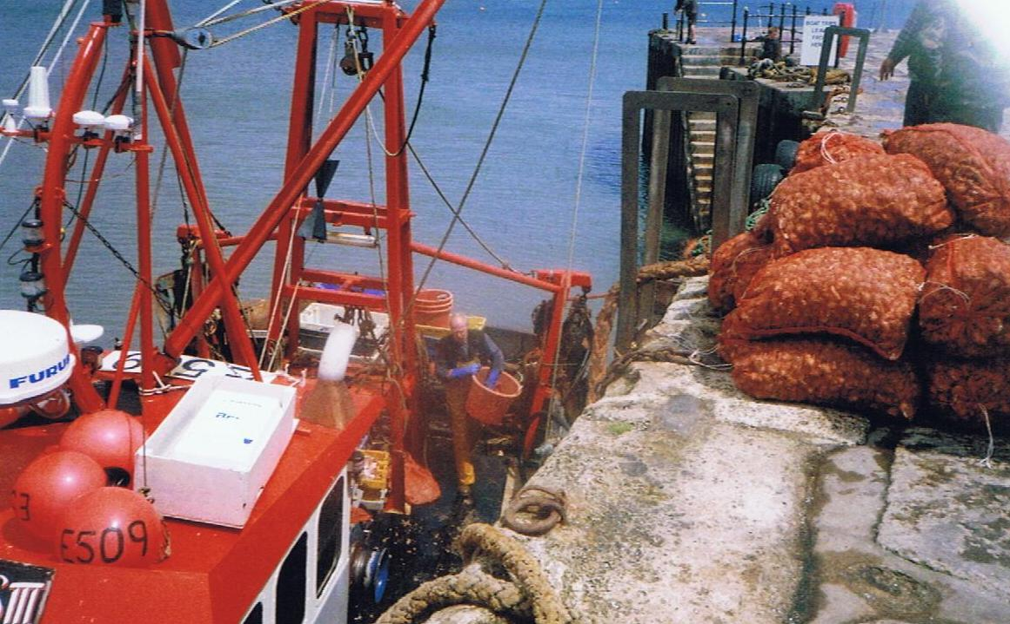
Photograph 4 – Fishing boat discharging cockles at harbour mouth at low water
5.8 Charter Boats
There are 14 trip charter boats licensed to operate from Lyme Regis. These variously provide fishing/educational trips round the bay, sea angling, and diving activities. The majority remain close to the shore. All are MCA licensed under the latest Codes of Practice. There is some overlap between operating as commercial fishing boats and as day charter fishing boats, 2 boats have dual licenses.
5.9 RNLI Lifeboats
There has been a lifeboat station on the historic Cobb since 1826. This station is now home to the RNLI and an Atlantic 85 class lifeboat.
5.10 Passenger Ships
Lyme Regis infrequently receives passenger cruise liners, It is hoped that the port could become a regular part of the Cruise liner itinerary.
In addition, day trip charter boats take ‘round the bay’ excursion traffic.
5.11 Hazardous Goods
Apart from small quantities of fuel for the port’s boats, no hazardous goods are handled at either port.
5.12 Port Management and Marine Safety
Traffic movement is left to the skippers of craft on the move. At Lyme Regis more direct intervention by harbour staff is necessary at peak times, as many people unfamiliar with the harbour, and indeed unfamiliar with boat handling, use the harbour at these times.
The Harbour Master has reserved rights to direct vessel movements and determine priorities when the need arises. Given the excellent safety record of the port there seems little point in changing the simple direct intervention methods which have been so effective.
When required, navigation control is carried out by the Harbour Master or his assistants by direct intervention from their patrol boats, the quayside, or by VHF radio. There are no formal navigation control centres. The port is equipped with a fast patrol boat, used both within the harbours and to police the beaches and inshore waters around the harbour.
5.13 Communications
When the Harbour Master is in attendance he listens and works on VHF Channel 16 and Channel 14.
5.14 Collison Regulations
Vessel movements are carried out in conformity with the provisions of the International Regulations to Prevent Collison at Sea 1972, as amended.
5.15 Speed Limits
A speed limit is in force within the harbour at Lyme Regis. ‘Dead Slow’ is the requirement with an understanding that this means minimum steerage way.
5.16 Vessel Traffic Service (VTS)
There is no VTS service at Lyme Regis.
5.17 Pilotage
There is no pilotage service at Lyme Regis except by request. The harbour is not a CHA and has no duty to provide pilots.
No pilots are authorised; should any vessel request the services of a pilot at either port, the harbour master could go ahead of the incoming vessel in his RIB, to be followed.
Advice and guidance is given by VHF to larger craft coming to anchor outside the harbour.
5.18 Passage Plan
As there is no pilotage service, there is no requirement for a formal passage plan into the harbour to be in place. A pilotage plan for large vessels coming to anchor has been drawn up. The Harbour Master will give advice to visiting craft on request.
5.19 Training and Qualifications
The SHA requires its Harbour Master to have had suitable harbour experience.
Each year one aspect of the port’s emergency response regime should be subject to a full-scale response exercise and the other aspects are subject to refresher training with all relevant equipment surveyed and checked as necessary.
The Council operates a staff appraisal scheme when the training, further qualifications, or revalidation needs of all staff are assessed.
5.20 Dangerous Vessels
The Dangerous Vessels Act of 1985 defines a dangerous vessel as:
1) One which poses a grave and imminent danger to the safety of any person or property within the port;
2) One which may, by sinking or foundering in the harbour, prevent or seriously prejudice the use of the harbour by other vessels.
Harbour Masters have powers to deal with such vessels and may give orders to the owner, master, or any other person, including a salvor, who may be in charge of such a vessel.
If it is practicable to do so, the first step should be to require the person in charge of a dangerous vessel to make it safe immediately. If they are unwilling or unable to do so, the Harbour Master may take steps himself to make it safe or to remove it, having a usual lien over the ship for the cost of doing so.
In many cases a vessel will become dangerous very rapidly and leave no time for considered action. The port’s emergency plan must be initiated, according to the problem the dangerous ship has. The Harbour Master’s duty is to protect life and property, while ensuring that his port can continue to operate.
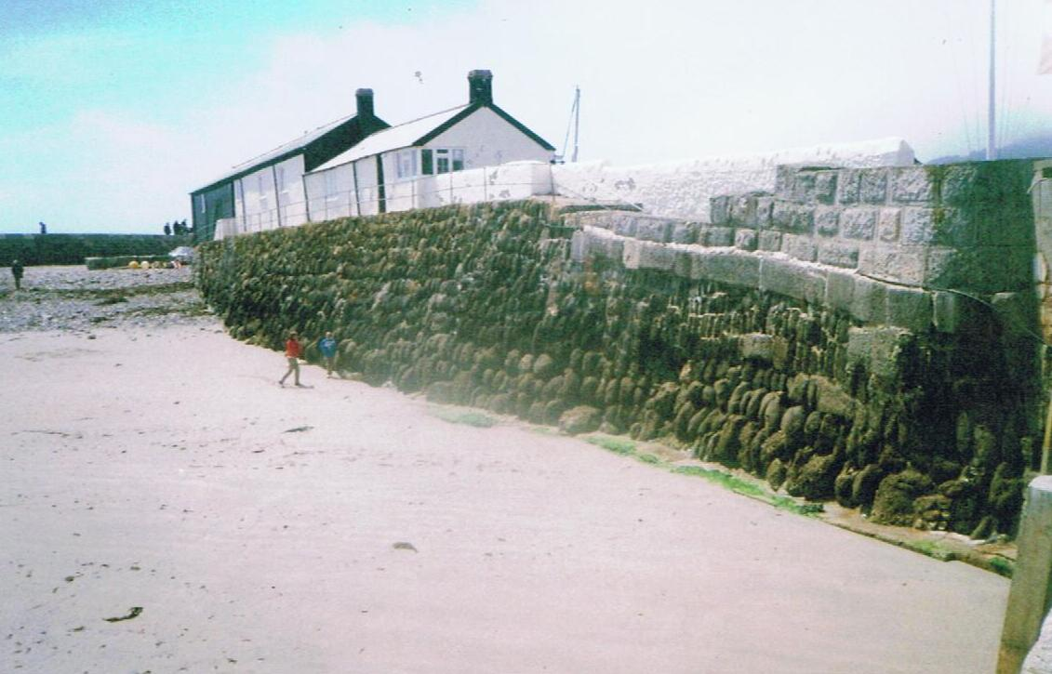
A port is not bound to accept from sea a dangerous vessel which requests entry, but the 1985 Act states that in making a decision the Harbour Master must have regard to the safety of any person or vessel, whether in or outside the harbour.

Photograph 5 – Rear of Cobb wall in outer basin showing original construction
5.21 Wrecks
There are no wrecks close to Lyme Regis harbour.
Port authorities have a common law duty to ensure that their harbours are safe for navigation and, equally, to warn ships using the harbour of any hazards within its port. Wrecks are an important consideration within this duty.
In the first instance, anybody having control of a wreck has a duty to remove it and Harbour Master is entitled to demand that it be removed forthwith.
That said, Harbour Masters have powers to deal with any wrecked vessel which is, or is likely to become, an obstruction or danger to navigation or to lifeboats within his port or its approaches.
These powers are:
(a) To take possession of, and raise, remove, or destroy the whole or any part of the vessel and any other property to which the power extends;
(b) To light or buoy the vessel or part of the vessel and such other property until it is raised, removed or destroyed.
Beyond this, the Secretary of State has general superintendence throughout the United Kingdom of all matters relating to wreck. He is entitled to appoint a special representative (SOSREP) to exercise those powers on his behalf, or to appoint a Receiver of Wreck. The Secretary of State may appoint a representative to take control of any incident, whether within a port or not, and Harbour Masters are required to co-operate in dealing with the incident.
SOSREP has a particular brief to prevent or control pollution and is most likely to take charge when pollution may be involved, but his derogated powers are not limited solely to this area.
5.22 Conservancy
At Lyme Regis, a set of leading lights bearing 284° (T) leads clear of the outer breakwater end and into the harbour. It is provided by two lights, the rear being a fixed green light visible 9 miles, the front an occulting sectored light showing red from the leading line to the South and West, white to the North and East. All permanent navigation lights at both ports are powered by mains electricity without emergency back-up, but as both ports are very largely daylight only operations, this is not considered to be a major problem.
A buoy has been installed outside Lyme Regis harbour entrance, to mark the end of a new sewer outfall. This is a south cardinal buoy, showing a standard flashing white light, in position 50° 43.17’N, 002° 55.66’W. Although not intended as such, it can be a useful fairway buoy for incoming small craft.

5.23 Standards and Inspection of Aids to Navigation
Dorset Council aims for a minimum of IALA standards, which for its ports is category two. Dorset Council is a local light authority and its aids have been subject to an annual inspection by Trinity House. The Panar system is in operation to cover the rest of the year.
5.24 Dredging, Hydrography and Admiralty Charts
Dredging at Lyme Regis is carried out each year in its approaches, and from time to time within the North East and South West corners of the harbour where a bank of silt and sand tends to build up. The South West bank is allowed to remain as much as possible as it gives good protection to that corner from more extreme weather. The main part of Lyme Regis harbour bed is firm and stable and does not require attention.
Lyme Regis harbour is surveyed twice a year, at the same time as Bridport, by a launch from the firm Shoreline Surveys. It examines the harbour and the seabed out the harbour limit. The surveys are done pre and post dredging. Any major changes are notified by a Notice to Mariners with a copy to the Hydrographer of the Navy.
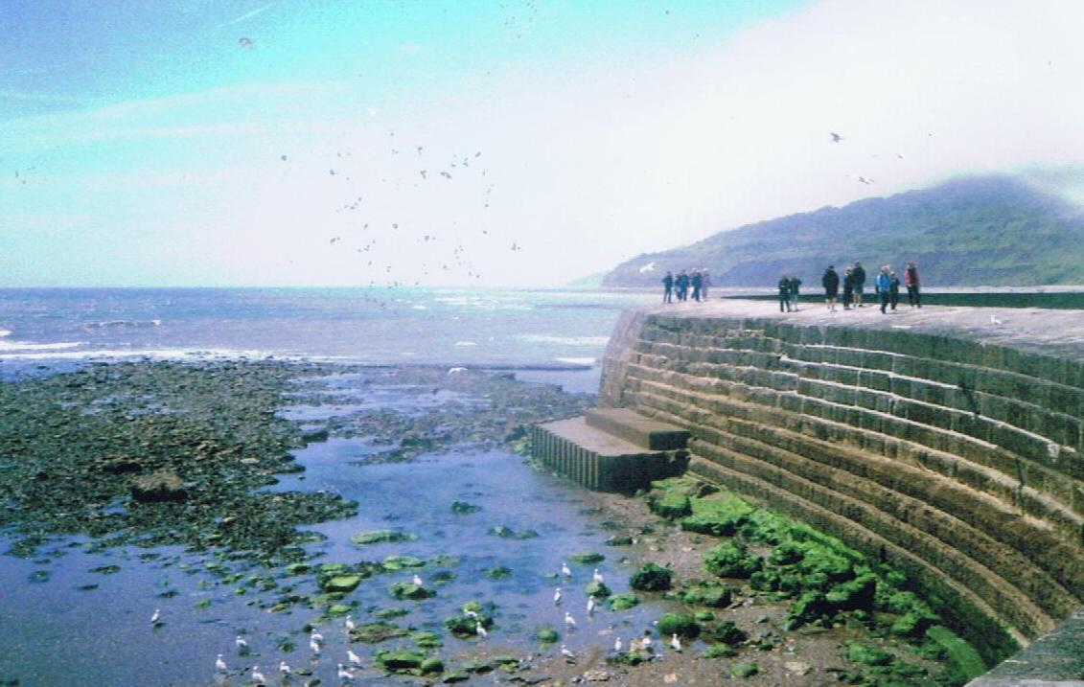
Photograph 6 – West side of Cobb wall showing modern construction. This section takes the full force of gale seas from the West.
5.25 Meteorology
Lyme Regis can be seriously affected by the weather. Lyme Bay is open to the Atlantic from the South-West quadrant, and very large seas can buffet both ports in strong gales. In addition, any wind from the south can very quickly kick up a short sea uncomfortable for small boats.
Green seas come right across the Cobb from time to time in severe weather. The Harbour Master is entitled to fly a red flag from the yacht club’s flagpole on the end of Victoria Pier when launching is prohibited. He can fly the hoist RY to slow vessels down.
Lyme Regis is less affected by weather from the SW than Bridport; therefore, if any boats at sea are unable to make Bridport, it is usually possible to shelter in Lyme Regis.
Movement is considered to be largely self-regulating: the boats only operate by day and if bad weather is expected imminently, or the entrance is difficult of exit, boats do not go out and hence the need to provide protective measures for craft struggling to make the entrance is minimised.
5.26 Tugs
There are no tugs available at Lyme Regis, the nearest source being Portland or, for a smaller tug, Weymouth. See Emergency Plan.
5.27 Works Licensing
All Major works in both ports are either carried out by direct labour of Dorset Council, or by contractors directly controlled by the Flood and Coastal Erosion Risk management Team so the need for licensing is minimised. Works carried out are agreed with the Harbour Master and controlled by the Principal Engineer in consultation with Dorset Council officers. It is rare, other than dredging, for such works to affect navigation. Minor works may be carried out directly by the harbour master or his assistants.
5.28 Event Management
Lyme Regis hosts many events through the year, and an informal level of risk analysis, along with a high degree of organisation, has always gone into planning these events.
The ‘Guide to Good Practice’ annexed to the Port Marine Safety Code requires risk analysis to be carried out fully by the organisers before any event is allowed to go ahead, and the results of the risk analysis must be given to the Harbour Master.
In turn the Harbour Master must be satisfied that the event meets the requirements of the Coastguard, the RNLI, and the shore-based emergency services. Where a national body represents the type of craft taking part in an event, any guidance or code provided by that body should be adhered to.
It is up to the organisers of each event to carry out their risk assessment of their event. The Harbour Authority ‘notes’ each risk assessment presented by the organisers of events, and unless it chooses not to approve them they can go ahead. It is normal for events to be insured and it is felt that, providing the insurers are willing to accept and underwrite the event, this should be enough for the Harbour authority.
When submitting their risk analysis, event organisers must also advise:
- Names of event organisers and officials;
- List of participants;
- List of authorities consulted;
- Timetable and programme of events;
- Arrangements for controlling the event, including any special communications;
- Any navigational constraints being imposed such as restricted areas or partial port closures;
- Emergency arrangements;
- Media arrangements.
This listing goes to the Dorset Council’s Property Services team.
Any additional resources required from the Harbour Master, the Council or the emergency services will normally be at the expense of the event organiser.
5.29 ISPS
The Department of Transport Certificate of Port Facility Plan has been placed on retention since cruise liner traffic has significantly reduced.
- EMERGENCY RESPONSE PLAN
6.1 Assigned Areas of Responsibility
6.1.1 All Vessels in the Harbour Approaches
HM Coastguard is the co-ordinating authority for any incident in these areas and will call in other services as necessary.
6.1.2 Craft in the Harbour
The Harbour Master has a primary authority for dealing with incidents to vessels on the move farther into the harbour, calling in other services as necessary.
6.1.3 All Craft Alongside in the Harbour
Craft alongside a berth come under general shore emergency provisions, which means that the police have the controlling responsibility, in co-operation with the Harbour Master as appropriate.
6.2 SOSREP
The Secretary of State has general superintendence throughout the United Kingdom of all matters relating to wreck. He is entitled to appoint a special representative (SOSREP) to exercise those powers on his behalf, or to appoint a Receiver of Wreck. The Secretary of State may appoint a representative to take control of any incident, whether within a port or not, and Harbour Masters are required to co-operate in dealing with the incident.
SOSREP has a particular brief to prevent or control pollution and is most likely to take charge when pollution may be involved, but his derogated powers are not limited to this area. The primacy of SOSREP is to be acknowledged in all marine emergency situations.
Action: For emergency assistance the RCC and CHA should be contacted.
6.3 THE PLAN
6.3.1 General
The emergency responses of Lyme Regis are under the overall command of their Harbour Master, reporting to the SHA duty holder.
The port only has the capacity to deal with minor incidents from its own resources. An incident at port level would require additional expertise and resources. Whilst a major incident is not envisaged, this would call for significant resources and expertise from external services.
Should an incident occur requiring further resources the Harbour Master will receive support and approval from the Head of Environment and Wellbeing and the Portfolio Holder for Highways, Travel and the Environment as Duty Holder.
A full-scale emergency would be initiated by the emergency services and would activate Dorset Council’s Emergency Plan.
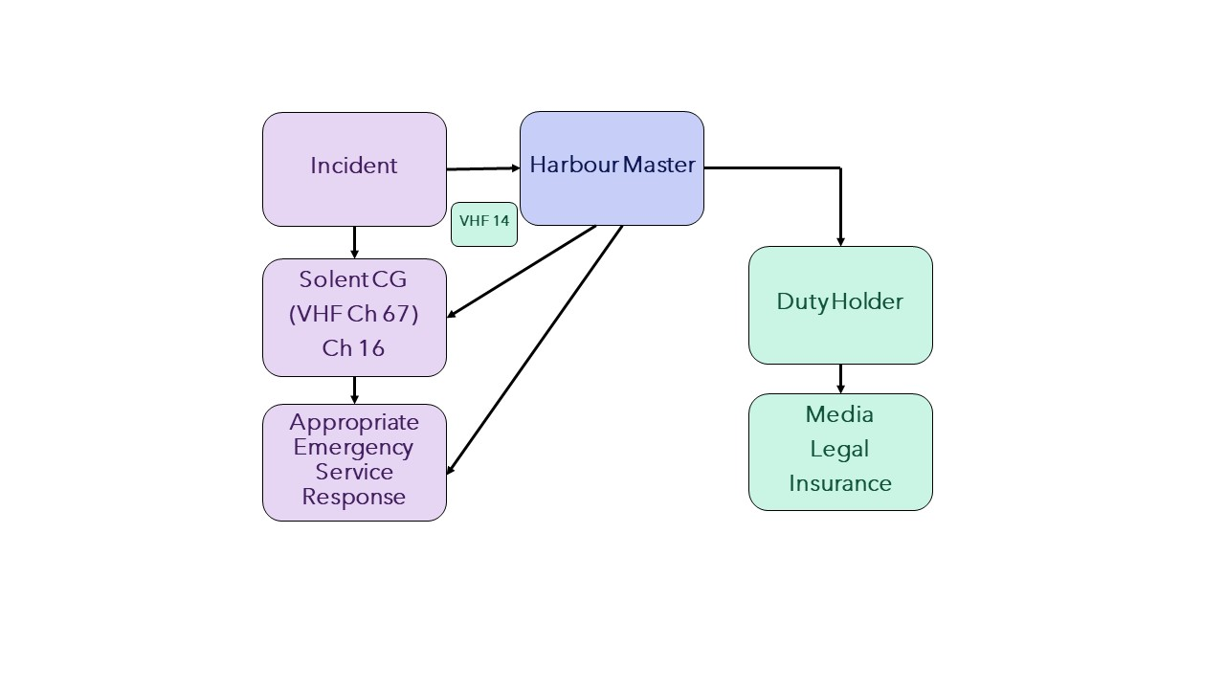
Figure 9 – General Emergency Response Flowchart
6.3.2 Pollution
Lyme Regis is exempt from the need to have a full Oil Spill Response Plan, but carries small stocks of pollution control equipment. This is located in the stores building and harbour staff are fully familiar with its use.
6.3.3 Tug and Salvage Equipment Availability
There are no tugs at Lyme Regis. The Harbour Master’s RIB is a powerful craft capable of being used for basic tug duties such as moving vessels around in the harbour. For incidents outside the harbour, it is probable that the larger fishing boats could give first aid assistance to smaller boats and these should be looked to in the first instance. The nearest large tugs are at Portland, 25 miles away and available to move on about half an hour’s notice in the daytime, 4 hours’ notice at night. Their draft limitations would preclude their use in the harbour or its approaches.
There is some limited salvage capacity at Portland, which could be mobilised reasonably rapidly. At Lyme Regis the usual way of dealing with the small craft which use it is by the boat lifter which operates across the harbour bed at low water. Any craft which sank would be lifted ashore at the next low water and dealt with from there.
6.3.4 HM Coastguard
The area National Maritime Operations Centre (NMOC) is at Lee on the Solent. The Senior Coastal Operations Officer (SCOO) is based at Winfrith, Wool; Lyme Regis has an auxiliary Coastguard Station which holds access equipment and shore support gear.
Solent Coastguard can be contacted by:
VHF channel 16 or 70 (DSC) or tel. 999
6.3.5 RNLI
There is an RNLI station at Lyme Regis with an Atlantic 85 lifeboat. To obtain lifeboat assistance, contact Solent Coastguard in the first instance.
6.3.6 Vessels Aground
As only small craft use the harbour, which is tidal, vessels aground do not constitute a significant problem. Any vessel capable of using the port, if it could not be towed off, would be removed at low water by crane or boatlift.
There can be a problem in the entrance to Lyme Regis Harbour if a larger boat moors by the steps. It can become grounded at low water preventing smaller boats still afloat from operating at or using the steps.
6.3.7 Wrecks
For emergency assistance the MRSC should be contacted immediately by 999. The SHA duty officer should be advised of the problem, the action being taken and any action required of the SHA.
Lyme Regis Fire Brigade will attend any vessel fire within the ports.
Action:
a) If alongside within the harbour, call Fire Brigade Tel. 999.
b) If on the move, Call Solent Coastguard VHF Channel 16 or 70(DSC).
Notify:
- Position
- Whether able to reach an access point and if so which one.
- ETA at access point
- Scale of problem
- Number of persons on board
- Type of fire
- Type of vessel
- Type and nature of assistance required
6.3.8 Persons in Difficulties
a) Outside the harbour mouth:
Action:
- Call Solent Coastguard VHF Channel 16 or 70 (DSC)
Notify:
- Vessel name
- Inbound/outbound
- State of tide
- Speed of current
- Location
- Number of persons in the water
- Whether local assistance available
- Solent Coastguard will decide appropriate response and if necessary, will call the RNLI or other appropriate service.
b) Inside the harbour mouth:
When an incident is observed or the Harbour staff are informed, the Harbour Master or his assistant will ensure that the Coastguard is informed, take charge and co-ordinate the rescue until such time as the emergency services are established on site.
If time is of the essence and it is safe to do so, harbour staff may attempt to assist the person in the water and rescue them or move them to a safe location.

- REPORTING, ASSESSMENT AND AUDIT
7.1 Overview
7.1.1 External Reporting
The port authority is required to report to the appropriate external authority whenever a major incident, an environmental hazard, or a sub-standard vessel is within their port limits.
7.1.2 Internal Reporting Chain
The internal reporting chain within Dorset Council is short and effective.
The Harbour Master reports to the Environment and Wellbeing Manager. He in turn reports to the SHA Duty Holder. Staff concerned with harbour operations will report to the Harbour Master.
7.2 Continuous Assessment
a) The Harbour Master keeps the plans, policies and procedures under continuous review to ensure that they continue to provide best practice to nationally agreed standards.
b) At twelve-monthly intervals the process of continuous assessment is to be monitored. This will normally be done in the early spring before the main boating season commences.
c) Whenever change appears necessary under the continuous assessment process, affected parties are to be consulted before the change is implemented.
7.3 Investigation and Reporting
The reporting of events within the harbour has to be made to appropriate authorities whenever called for. Any physical checks or action required should be put in hand. Any event also triggers an immediate review of those aspects of plans, policies and procedures which are affected by it, to seek out and amend any deficiencies shown up by the event.
i) Incident reports by skippers to the Harbour Master to include:
- Near miss between boats
- Touching bottom when on the move
- Berthing and unberthing or mooring problems
ii) Status reports by Harbour Master or staff to Head of Environment and Wellbeing each week, to include:
- Incidents
- Moorings
- Aids to Navigation
- Safety Equipment around the Harbour.
- Access landings and ladders
iii) The Head of Environment and Wellbeing reports to the Duty Holder, as and when events require, and always in accordance with Section 2.2.
- Material condition of the harbour
- Reporting of incidents
- Operational difficulties
- Dangerous acts
- Port statistics
7.4 The Audit Trail
7.4.1 Introduction
The Port Marine Safety Code requires every port to carry out a full-scale review and audit of its entire safety system at intervals no greater than three years.
It is preferred that the review is undertaken by an outside body.
7.4.2 Twelve Monthly Review
The Harbour Master should monitor, that is make a more structured examination of the port’s workings, every twelve months at which time all employees should be formally asked if they have any inputs to make, and the duty holder consulted.
The following should be addressed:
i) Are the port’s legal framework, bylaws and directions appropriate, and if not, what amendments should be recommended to the Competent Harbour Authority?
ii) Is the port being operated in accordance with the requirements of the Port Marine Safety Code and the Guide to Good Practice?
iii) Are the policies, plans and procedures described herein being carried out? If not, why not? Does this plan require amendment or is there some deficiency in the managing and operating of the port?
iv) Have all statutory requirements, surveys and local regulations been complied with?
v) Have there been any incidents in the previous year which call for review of the Safety Management System?
vi) Have the elements of the operations plan all functioned to the level expected of them? If not, what remedial action is being taken?
vii) Have emergency systems been tested, and is progress towards or the results of the annual major exercise being developed?
viii) Have appropriate notices been given?
ix) Have any consultees affected by any activity in the last period been consulted, and with what results?
x) Are there any upcoming changes, events, or problems to be considered, and if so what action is being taken to prepare for them?
xi) What training has been carried out in the period, and what is planned both for the next period and the next year?
xii) Any other relevant considerations.
This monitoring should be recorded and signed by the Head of Environment and Wellbeing and Harbour Master and delivered to the Duty Holder by including it in the annual report with a recommendation that the Duty Holder (The Portfolio Holder for Highways, Travel and the Environment) accepts the report. Once satisfied with its contents The Duty Holder formally approves the report making comments as appropriate.
7.5 External Reporting
(a) Sub-standard vessels
Every port has a duty to report any sub-standard vessel or crew which visits the port in accordance with Notice MSN1832.
The procedure to be followed is as laid down in that notice. That is the Harbour Master will note and if necessary, refuse permission for any sub-standard vessel to enter or to move, advising the MCA. All advice should be in writing, signed and dated.
7.6 Reporting of Incidents, Accidents or Disasters
Other than emergency services, the external authority to whom ship damages, stranding’s, sinking’s, fires and other events concerning ships or crews should be reported to is the MCA.
7.7 Internal Investigation and Reporting
All significant unplanned events within the port must be investigated by the Harbour Master as soon as possible after the event.
All staff within the port must be trained to record the event, making contemporaneous notes.
Whenever possible photographs should be taken. Photographs taken at the time are sometimes a most powerful way of dealing with questions after the event.
The objective always is to ensure that there is sufficient evidence to be able to draw conclusions about the event. Such contemporaneous records can be very important also in providing information for insurance interests, and in providing the employer or authority with the information to deal with any claims which may arise.
Where it is not practicable to make contemporaneous notes, those involved should be debriefed by the Harbour Master as soon after the event as is possible. In all cases the record must be agreed and signed by all parties involved.
7.8 Reporting
Reports on all significant unplanned events within the port should be addressed to the chairman of the SHA, Duty Holder and Chair of the Harbours Committee by way of:
a) The Head of Environment and Wellbeing.
In addition:
b) Copies go to the Chief Executive, SHA.
c) The Insurance Manager.
d) Dorset Council’s Emergency Planning Officer.
7.9 Public Scrutiny
The plan showing conformity with the Port Marine Safety Code has to be available for public scrutiny. A copy of the latest plan should be lodged in a public place such as a library or available at the Harbour Master’s Office. As an alternative, posting the latest plan on the Harbours website satisfies the Code’s requirement that the plan should be publicly available.
Port Marine Safety Code - Lyme Regis Harbour

